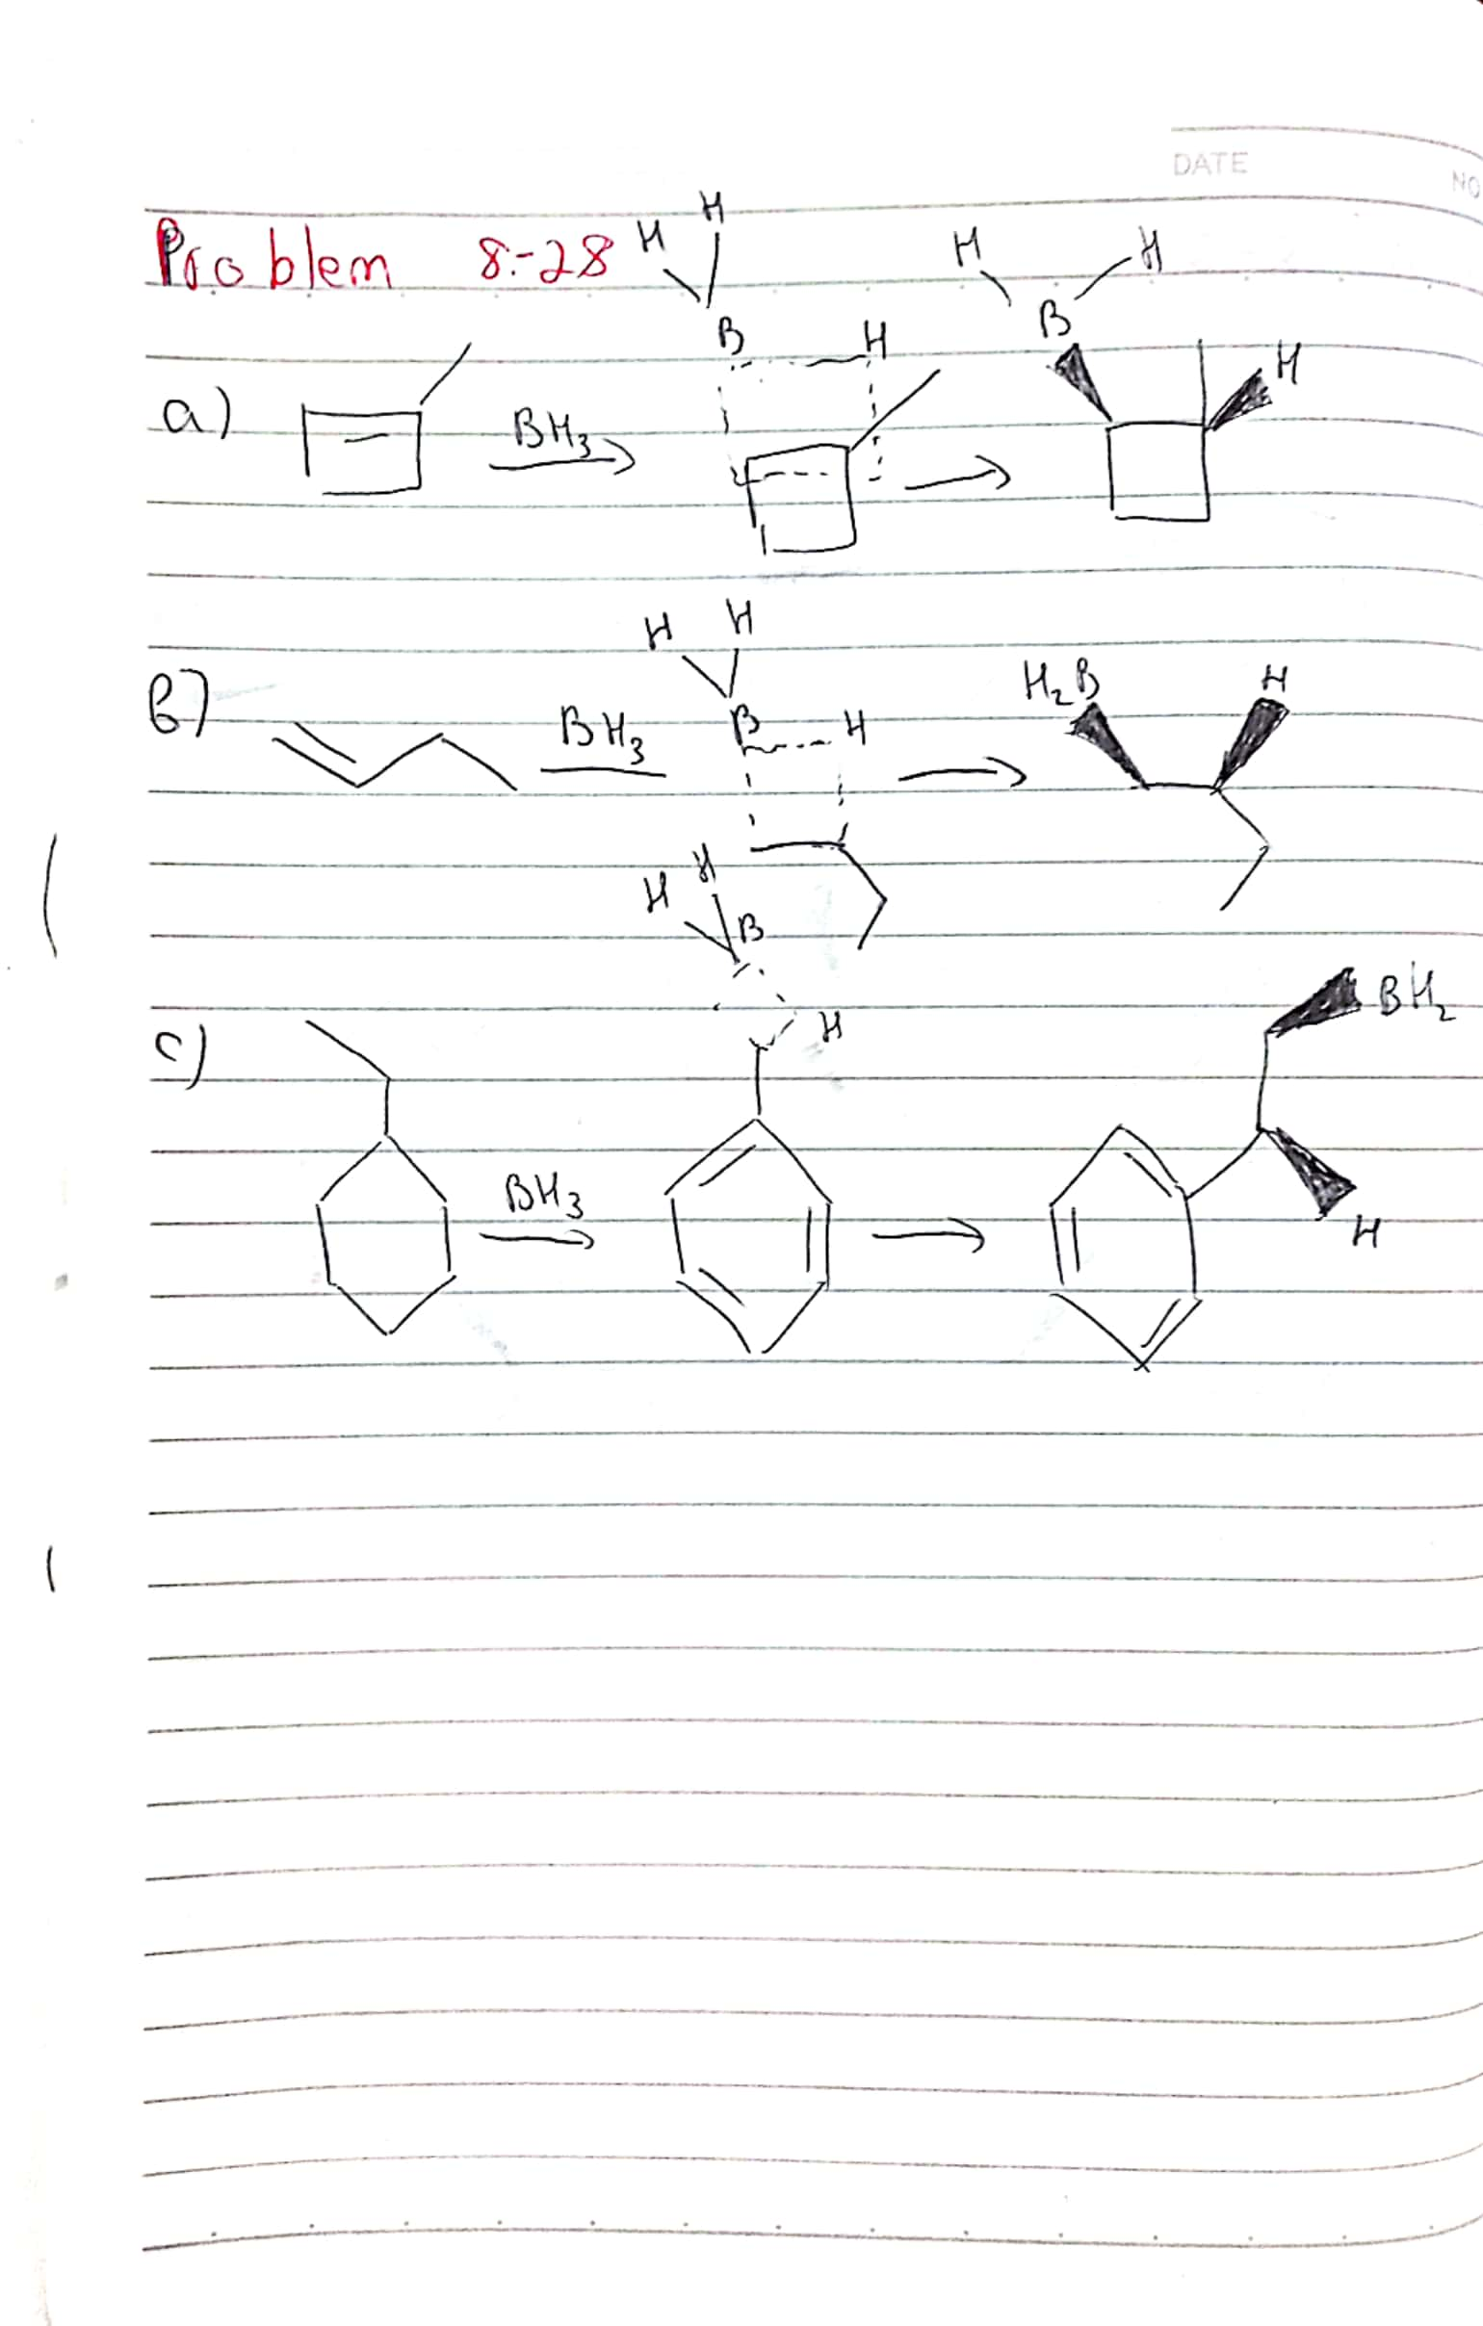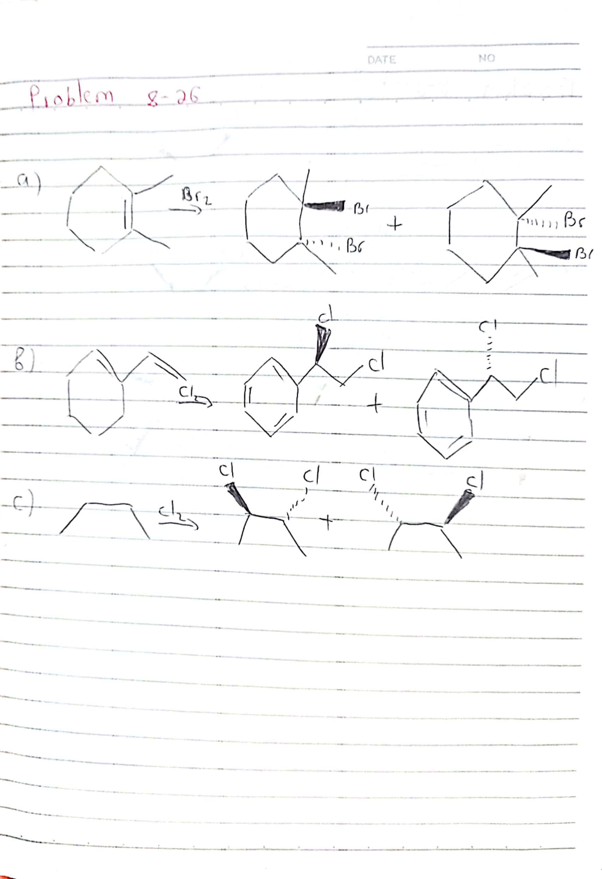

Student Id : 201923250

Name : Kobilov Ilkhomjon

Thank you